**Php code file website deployment through Jenkins(webhooks) on ec2 instance**

**In first instance:**

* apt update
* apt install php -y
* cd /var/www/html/
* ls
* git clone https://github.com/adityaglobe/workspace
* ls
* cd workspace/
* vim /etc/apache2/sites-available/000-default.conf
* systemctl restart apache2

then copy the private IP of instance, copy on new tab



This will show.

* **Give full permission to html folder:**

Chmod 777 html

**Now install Jenkins in Second instance:**

* sudo apt update
* sudo apt install fontconfig openjdk-17-jre
* java -version
* sudo wget -O /usr/share/keyrings/jenkins-keyring.asc \ https://pkg.jenkins.io/debian-stable/jenkins.io-2023.key
* echo "deb [signed-by=/usr/share/keyrings/jenkins-keyring.asc]" \ https://pkg.jenkins.io/debian-stable binary/ | sudo tee \ /etc/apt/sources.list.d/jenkins.list **>** /dev/null
* sudo apt-get update
* sudo apt-get install Jenkins

**Now copy the IP of instance and paste it on new tab with :8080 and this will show: -**

**For password copy the path in terminal which is given**

**Install the suggest plugins**

**Go to manage Jenkins and install plugins:**

Publish over ssh

**After installation restart.**

**Go to system to configure the system**

**Click on system and go to the bottom and add SSH server**

**Fill the information:**

* Name= your index.php server name
* Hostname= your index.php server public IP
* Username= your index.php server OS
* Remote directory= /var/www/html

**Apply and save.**

**Now create jobs**

**Select freestyle project and enter the name of your choice:**

**Now enter your GitHub link:**

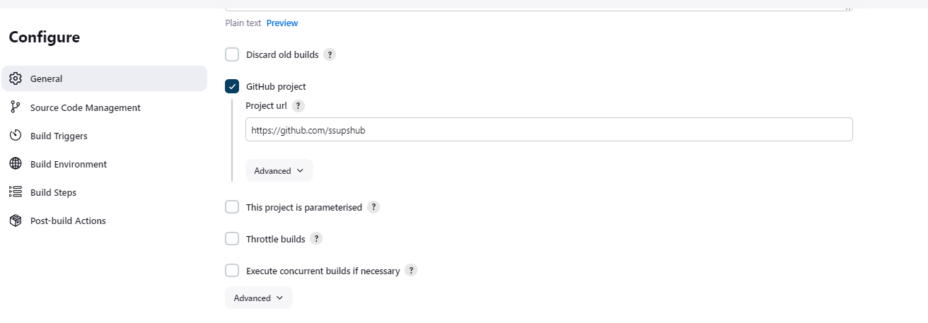

**Choose git and enter the Repository URL:**

**Select the GitHub hook trigger for GITScm polling to trigger your build:**

**For Tigger this you have to create a webhook in your GitHub account:**

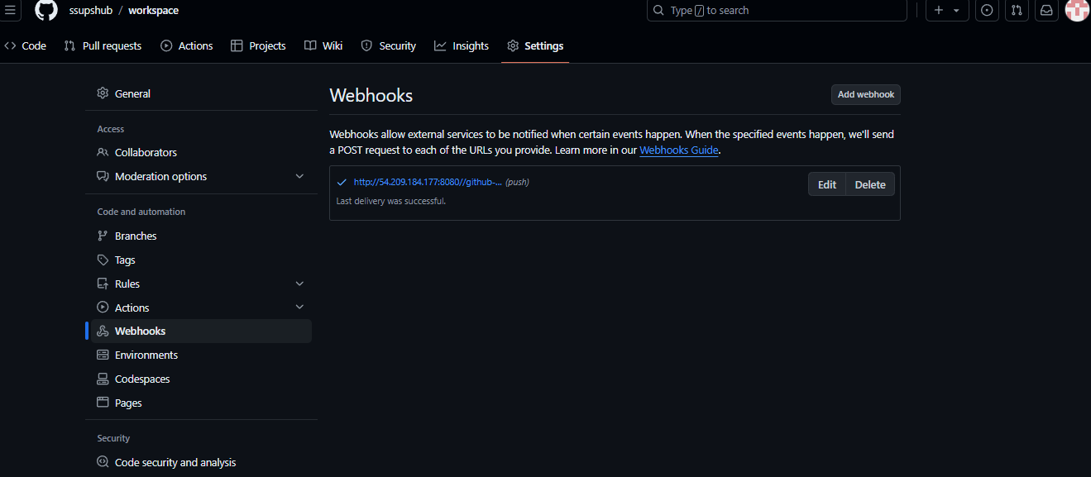

* Go to your GitHub account then project repositories
* Click on settings then you will see the webhook, click on it then paste your Jenkins server IP and create.

**Choose the third option in build environment**

**Now fill the details:**

* Source file= **/*.php
* Remote directory= /

**Now apply and save then click on build now.**

**After the successful build this will show: (ignore the 2#)**

**Now go to your GitHub repository and click on index.php:**

**Then change in the code:**

* From this

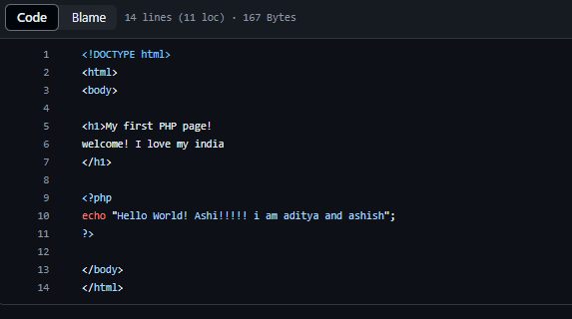

* To this

**This will show in Jenkins**

**Check the changes in website:**

